

Let me show you something

Abdullokh Askarov U1610005

Diyorkhon Mukhammedkhanov U1610257

Rodion Akhmedov U1610191

Shokhrukh Shokhnazarov U1610228

Umarbek Orifov U1610246

Git Hub repository: https://github.com/iuthub/design-project-bureau-profiler

Web site address: <http://bureauprofiler.000webhostapp.com>

Bureau Profiler company intended to help HR specialists to find highly qualified employees. And it creates opportunities for specialists in different areas to find their dream jobs.

If you have just graduated from University or you want to change your current job position feel free to register and create your portfolio so that other companies seeking for employees will find you.

BP web site consists of following pages:

**Home page:** introductory page that describes main goal of website

**Profiler:** this page will be available after registration and it will help you create and upload your portfolio

**Head Hunt:** is the page where HR specialists will be searching for employees and also your portfolio will be hanging out there

**Blogosphere:** coming soon (not available right now)

**Account:** this is your portfolio page

Let’s explore pages one by one and see how they were implemented.

**Home page:**

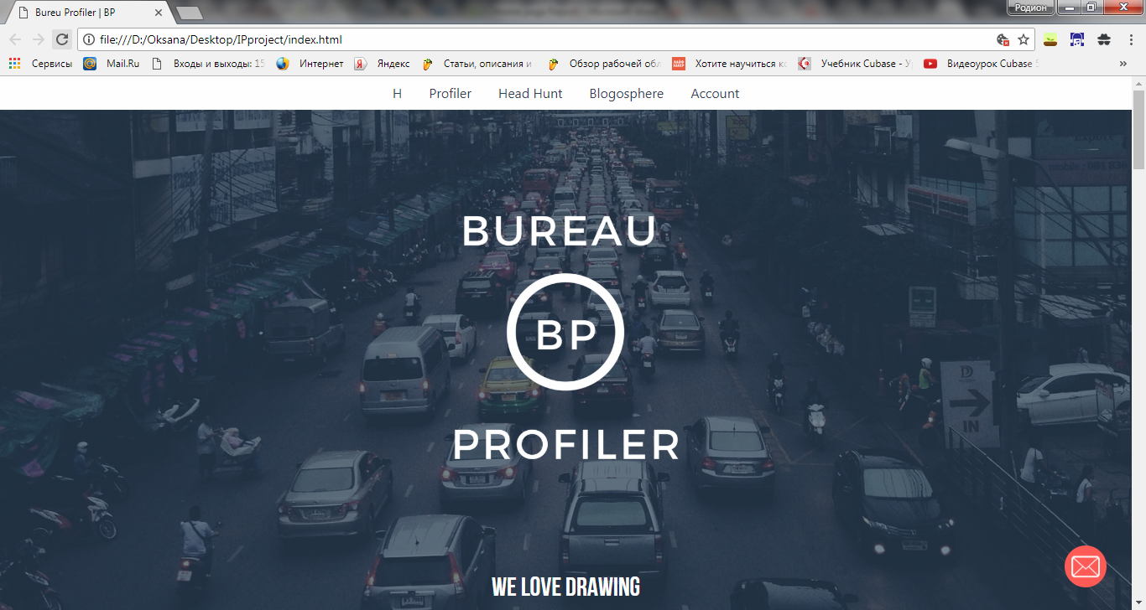

Home page introduce to what Bureau Profiler is

On first section you see bootstrap nav and hero image (made with graphic design tool)

BP is our symbol

“we love drawing” is javascript code that changes html on different content

Right corner is modal button that pop up a message

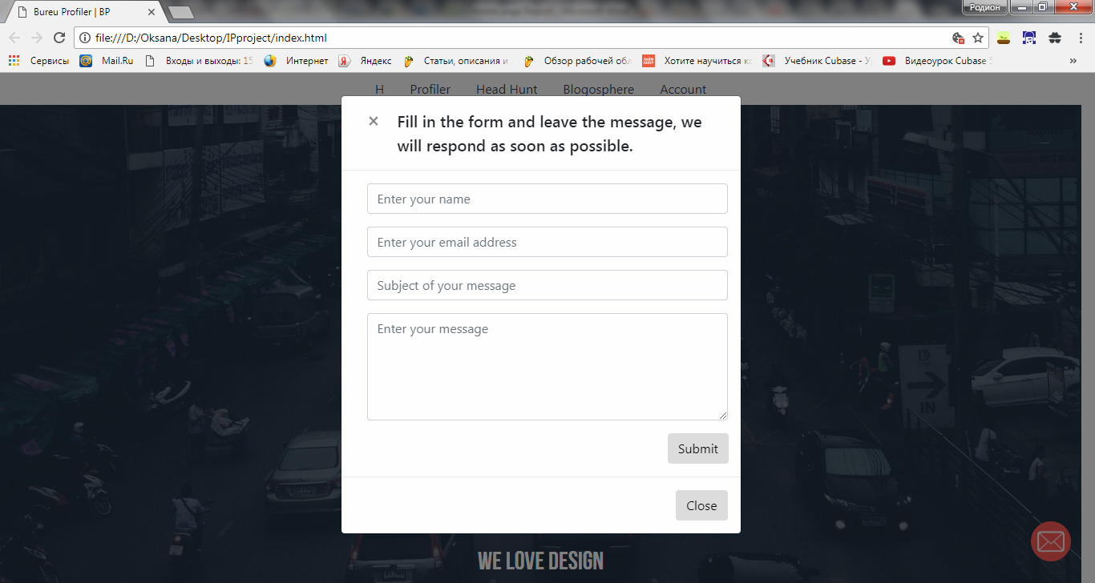

With data input validation

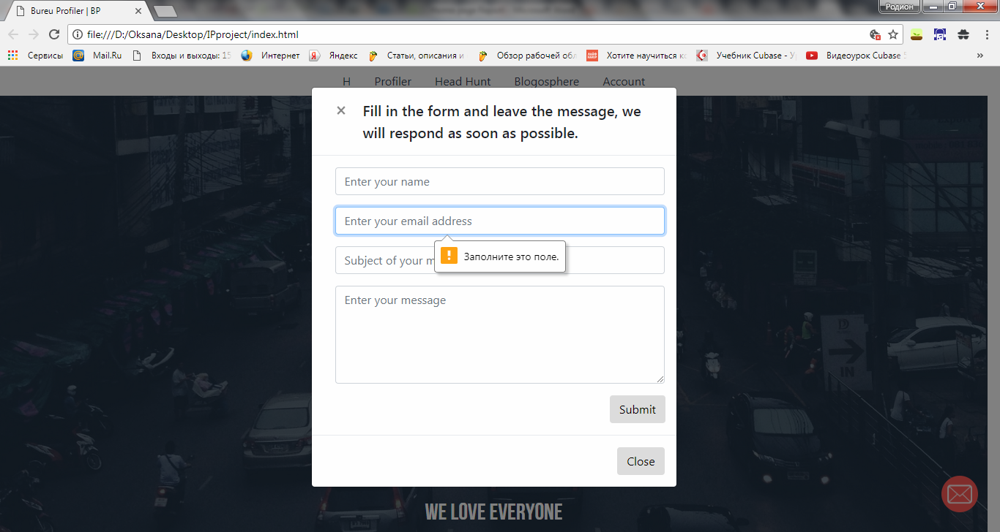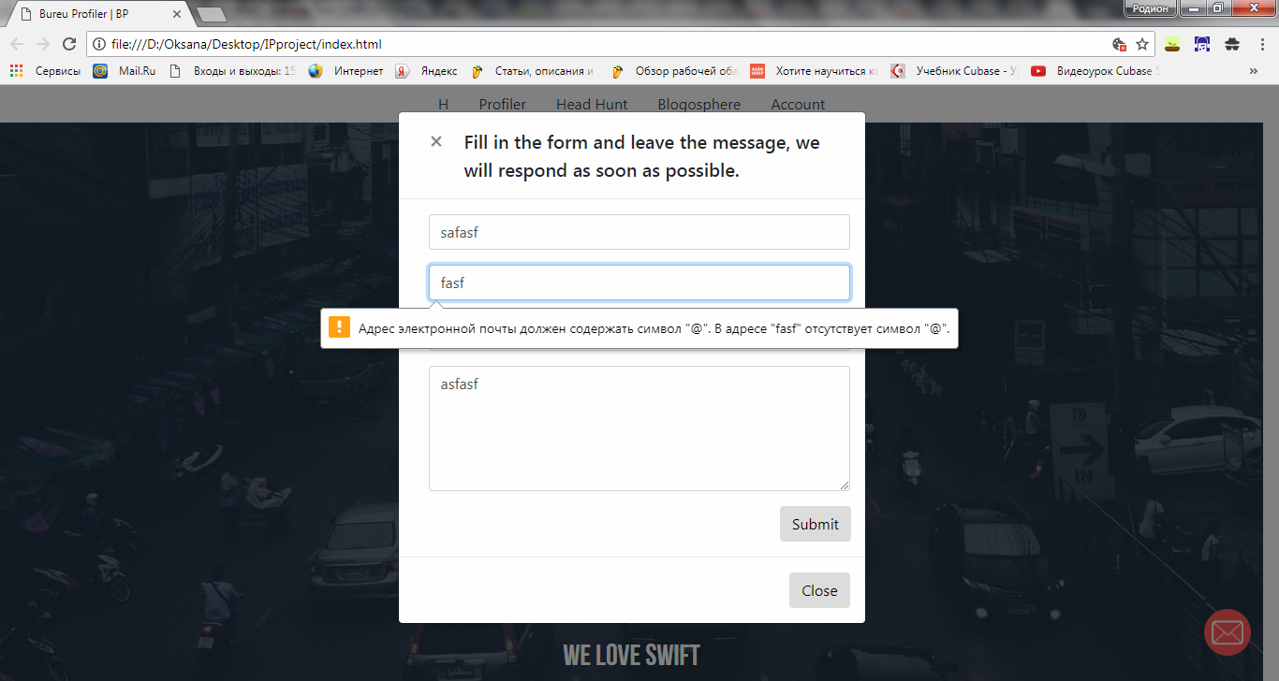

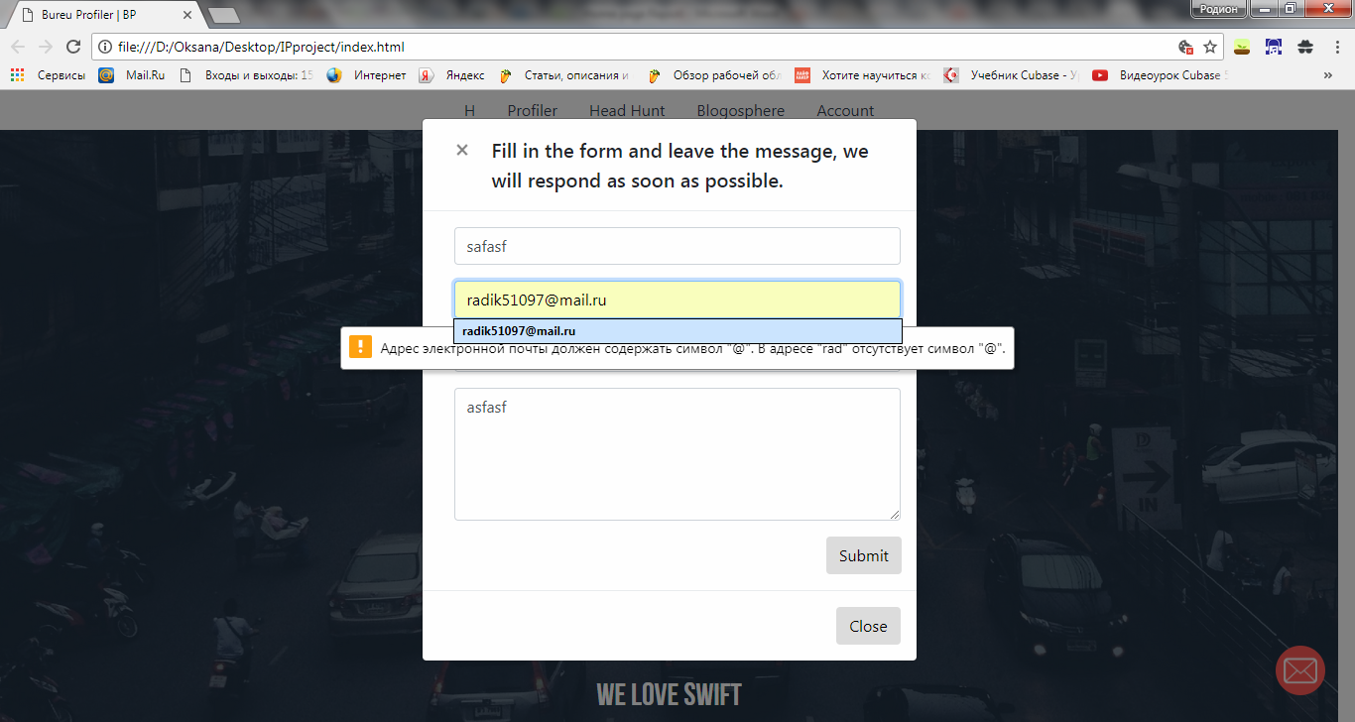

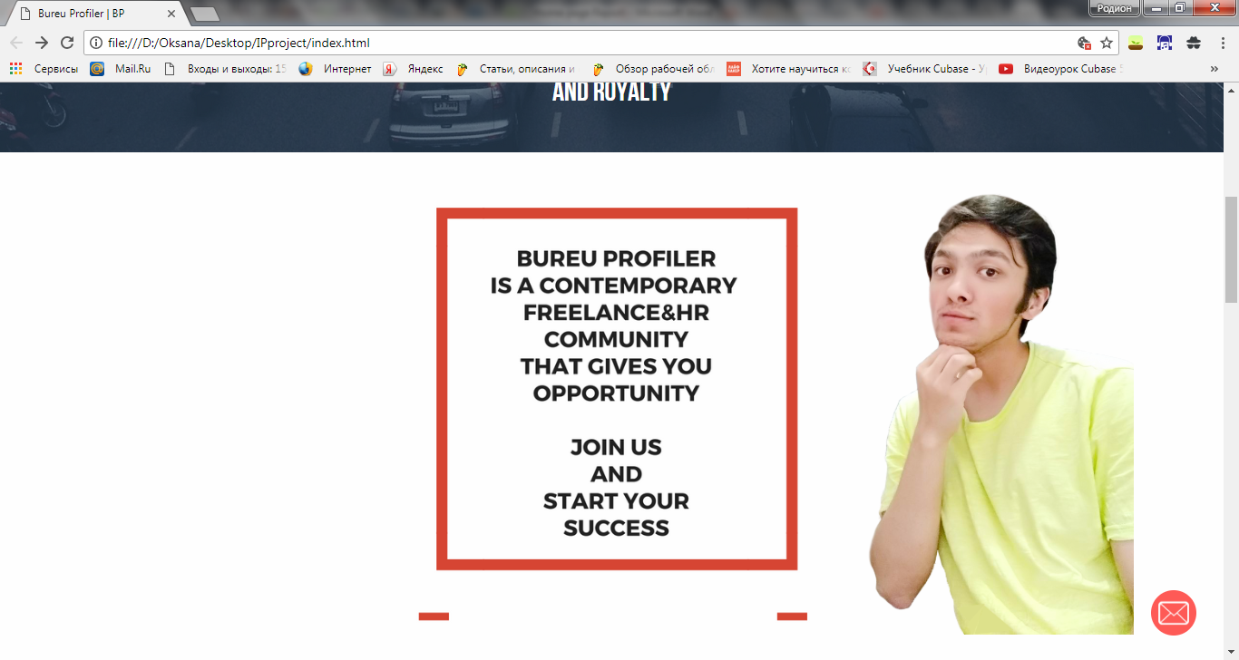

Here we are describing what is a general purpose that BP has

Red border’s image is a part of a parallax container (this is fixed background that it is not scrolled down).Right side is a one of our developer / as well as a metaphoric freelancer who is trying to get the idea of BP. Photo is scrollable

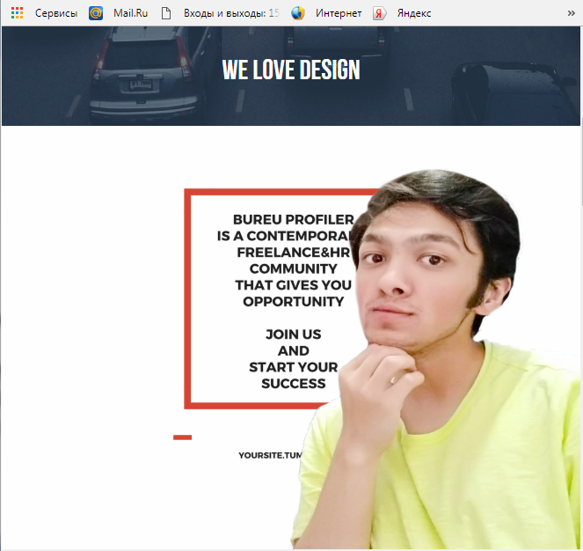 AND RESPONSIVE

Moving next,

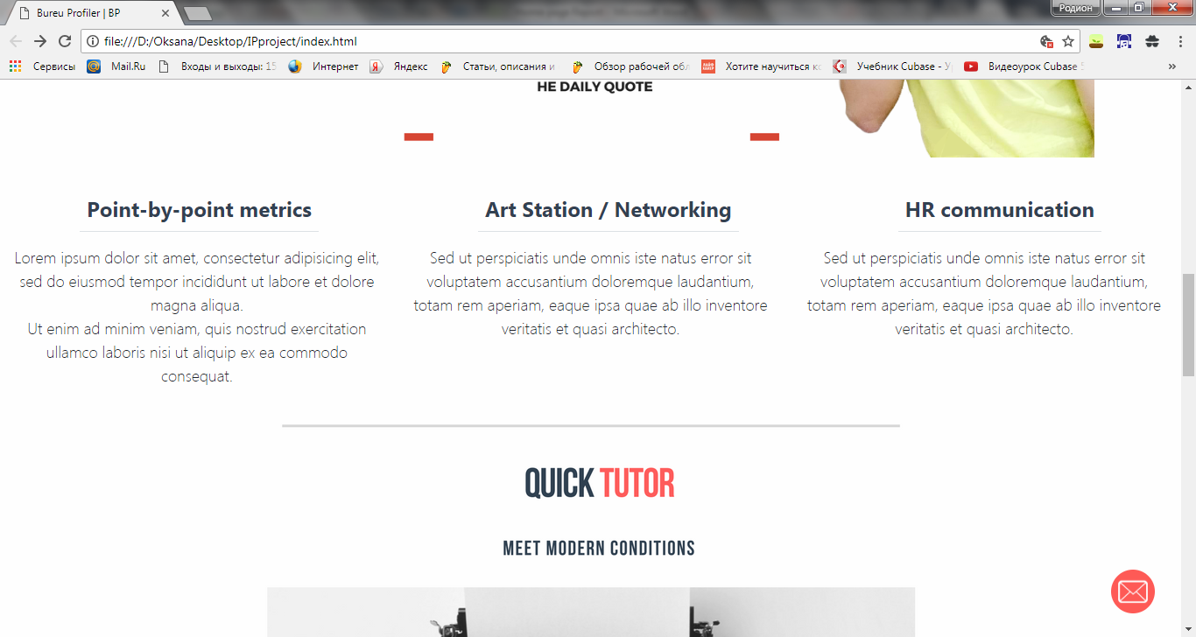

Flexbox layout that is divided in 3 columns prepared for detailed features

Art, Networking, Communications

Next section

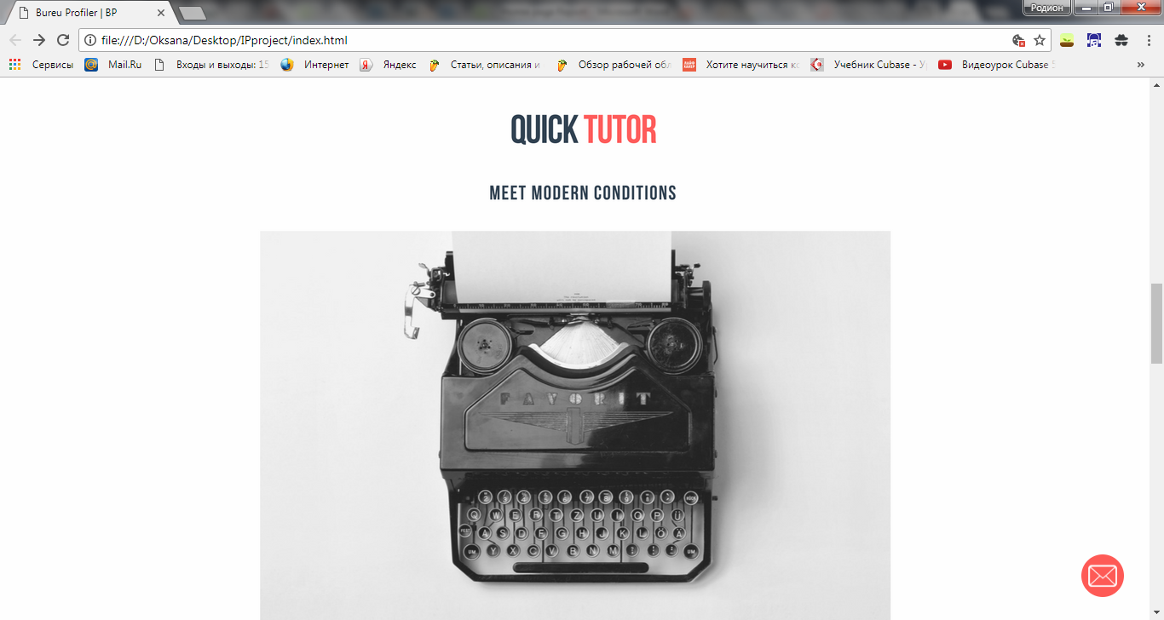

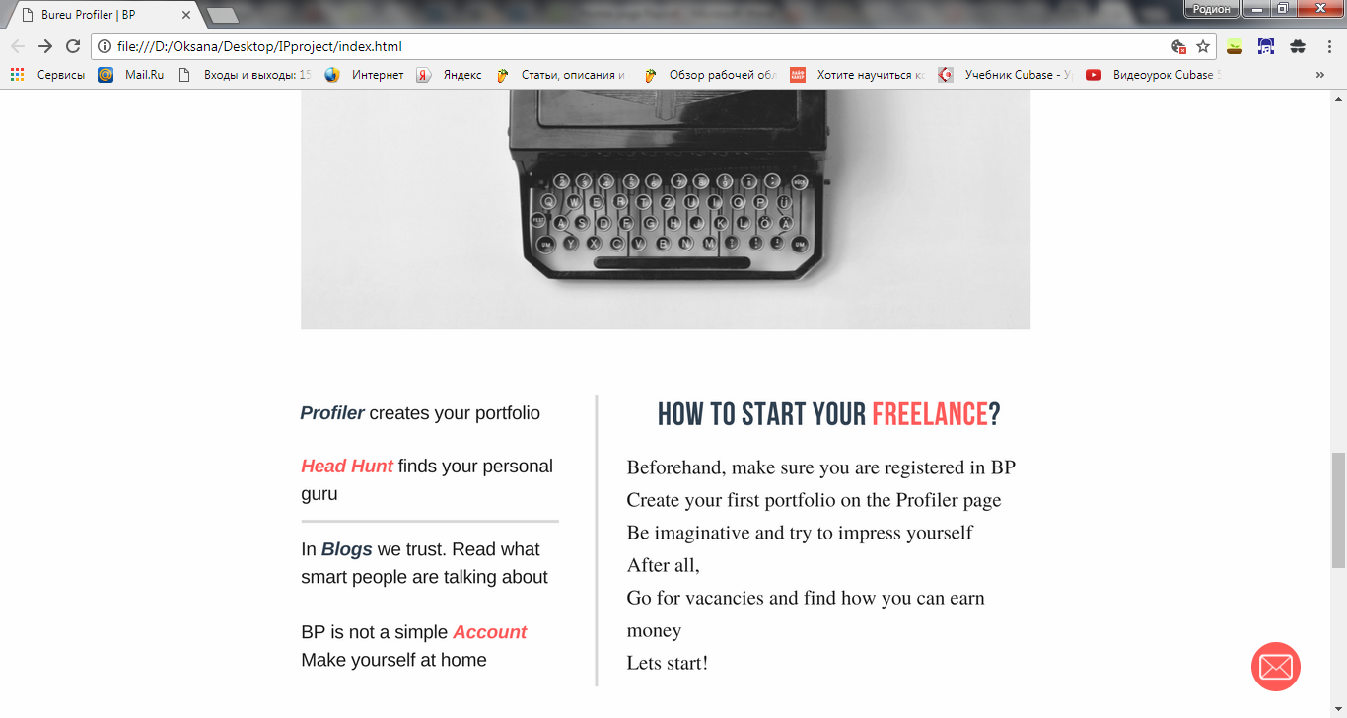

Demonstrates how to navigate on a web-site

Left side – tools on a nav

Right one- proper usage of tools

Then,

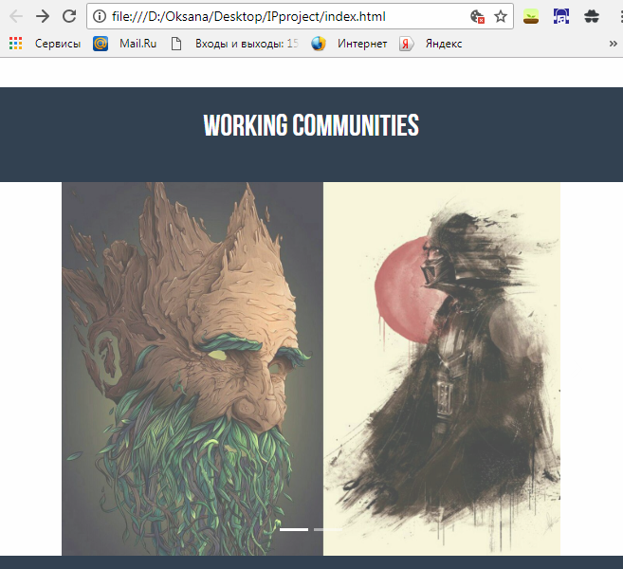

Working Communities are groups of people who are working by categories

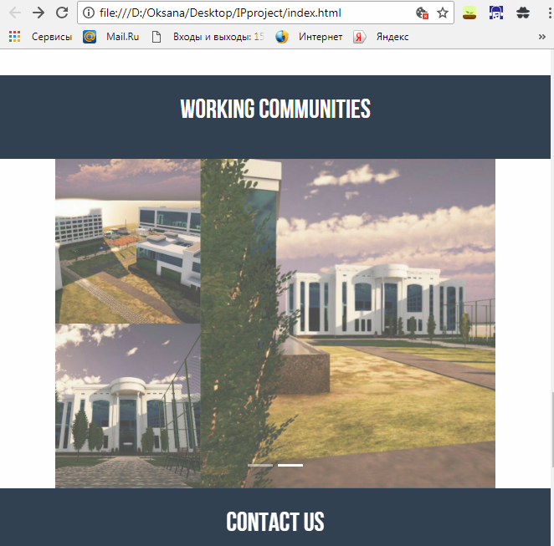

These screenshots of web-site in a collapsed format

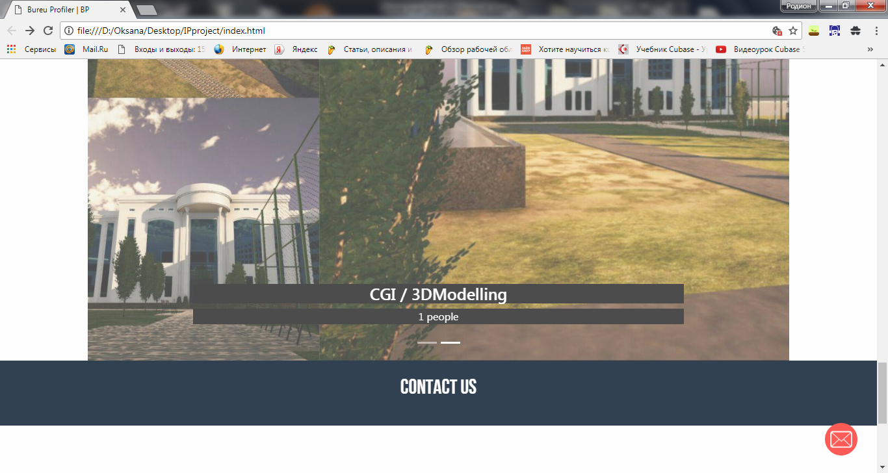

In normal way, one can see headline of a category

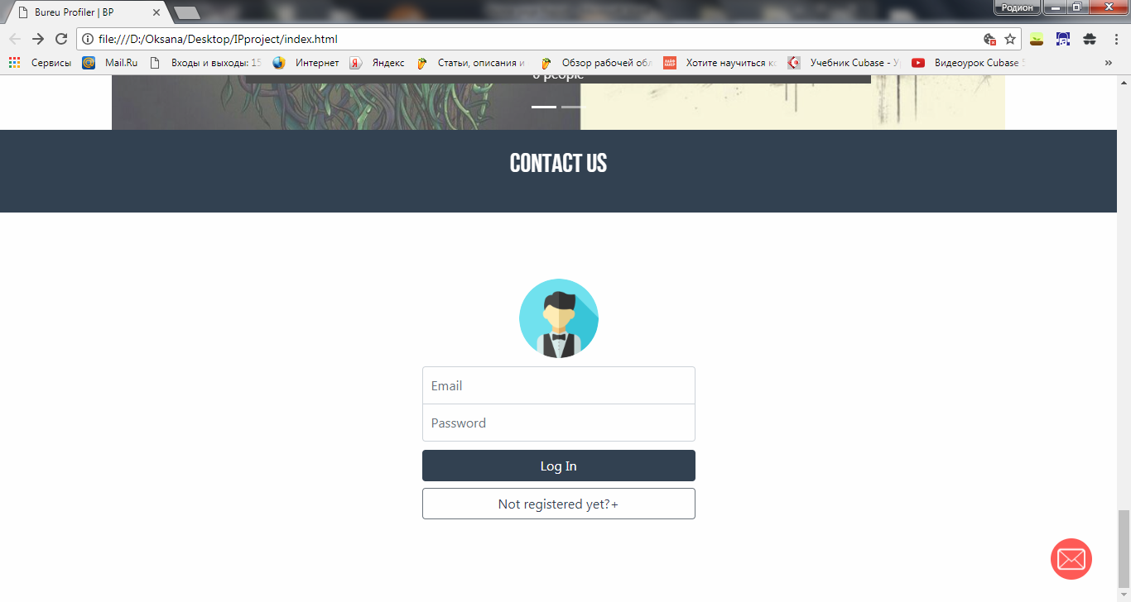

Footer was made in style of registration form

It is done with validation of data input (JS regular expressions)

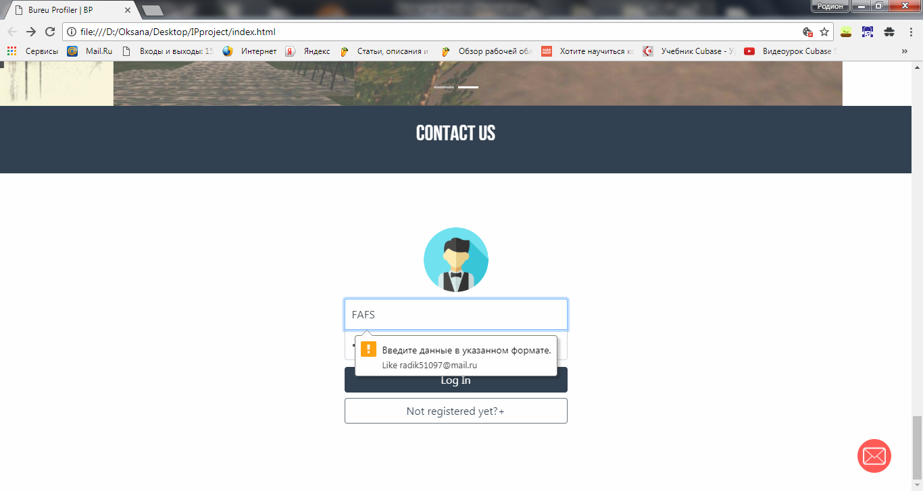

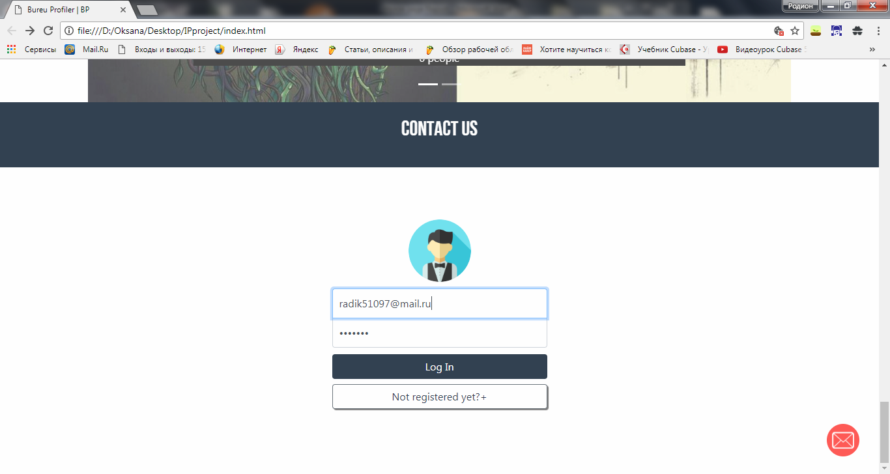

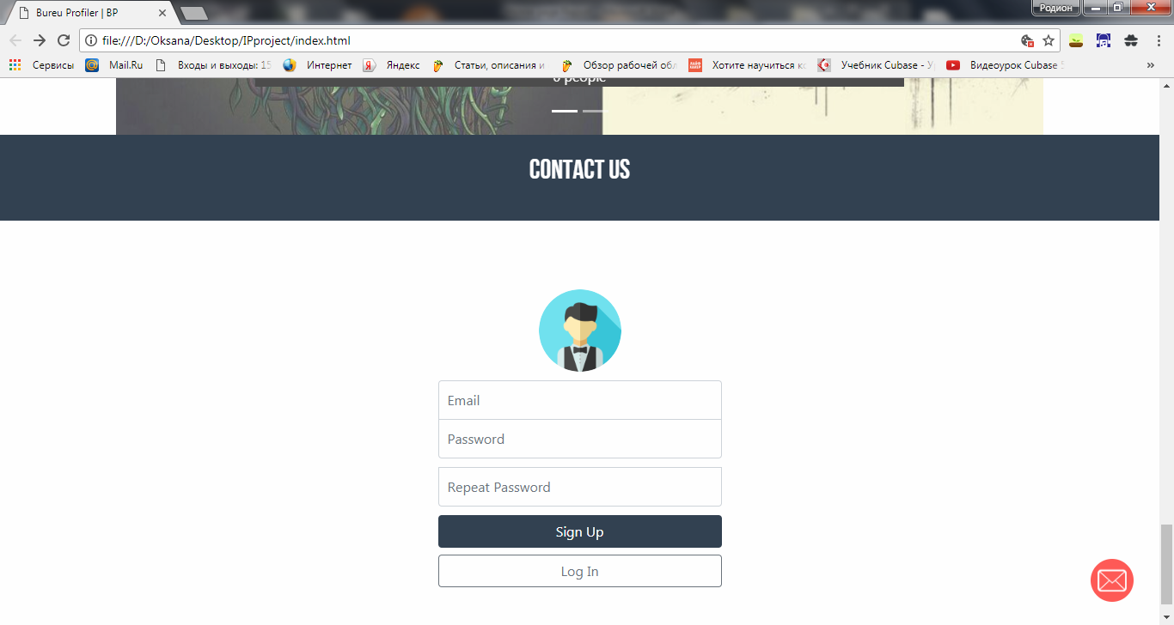

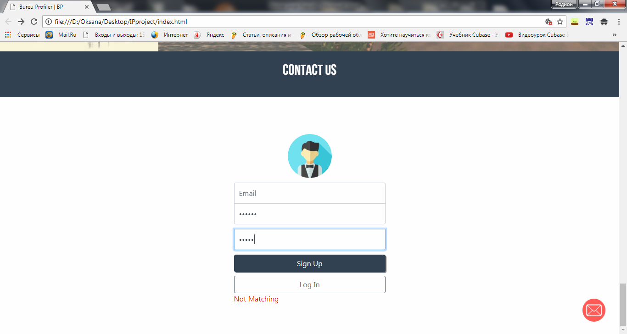Not matching is a message that shows no correspondence in passwords

Cannot be send

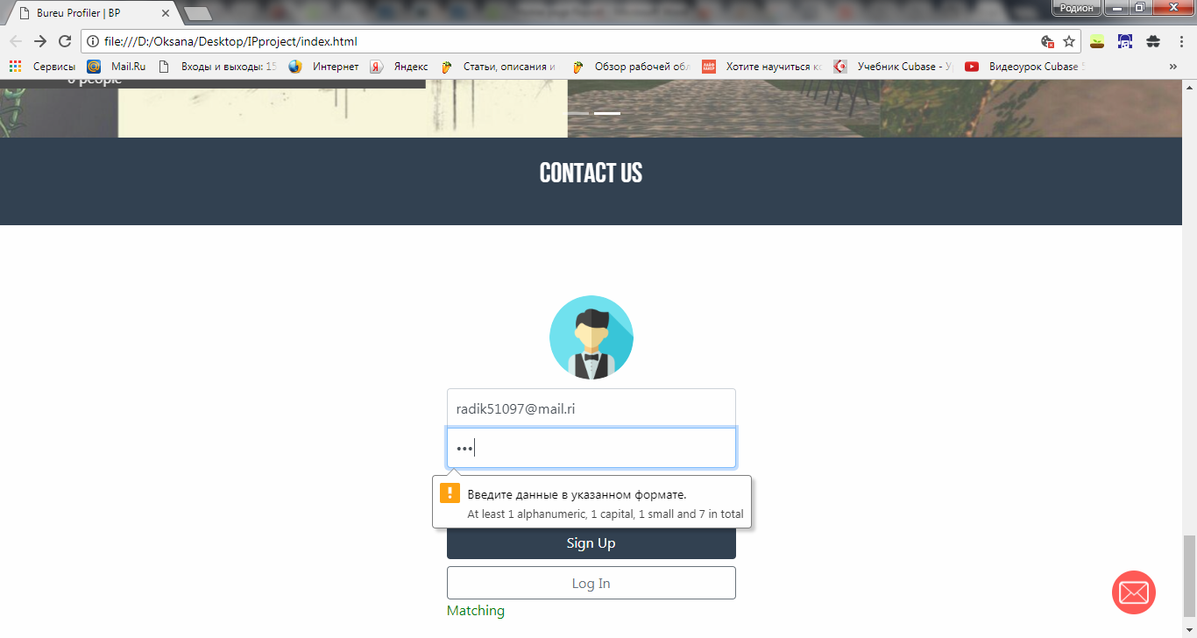

Even if passwords are matching they should follow security instruction

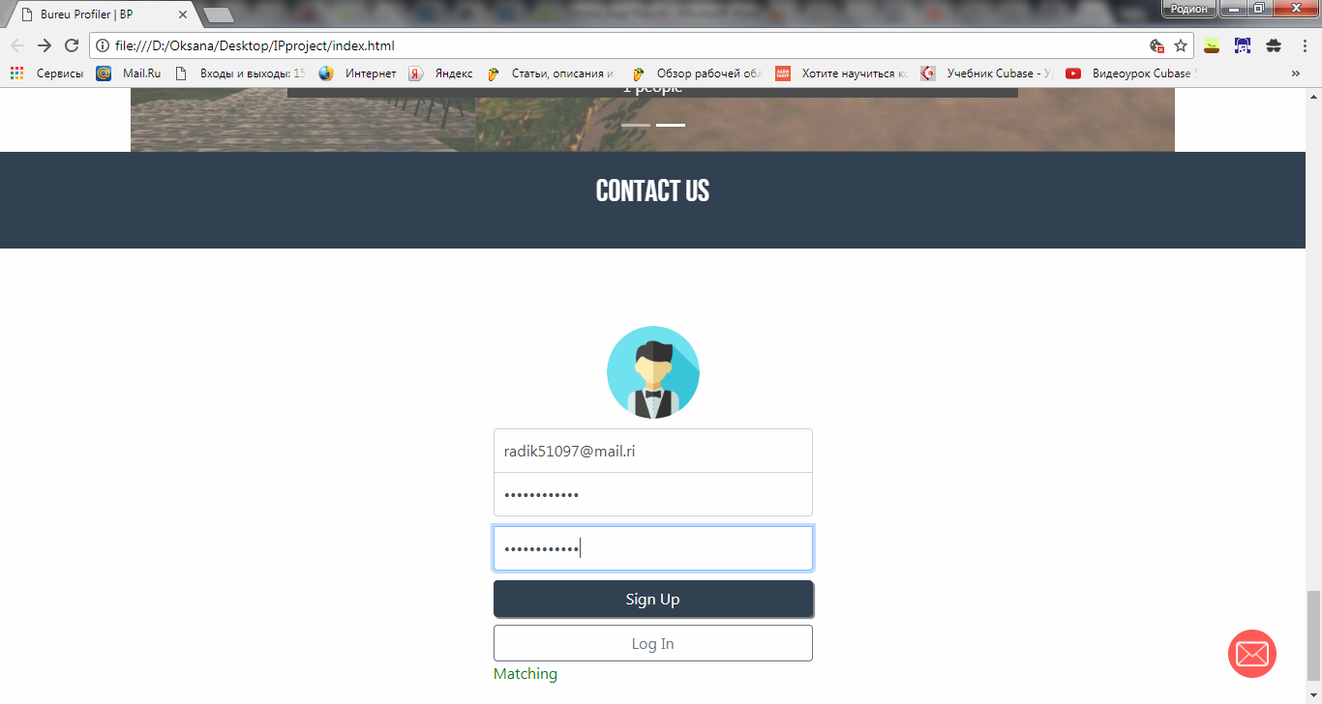

**Profiler:**

**Webpack**

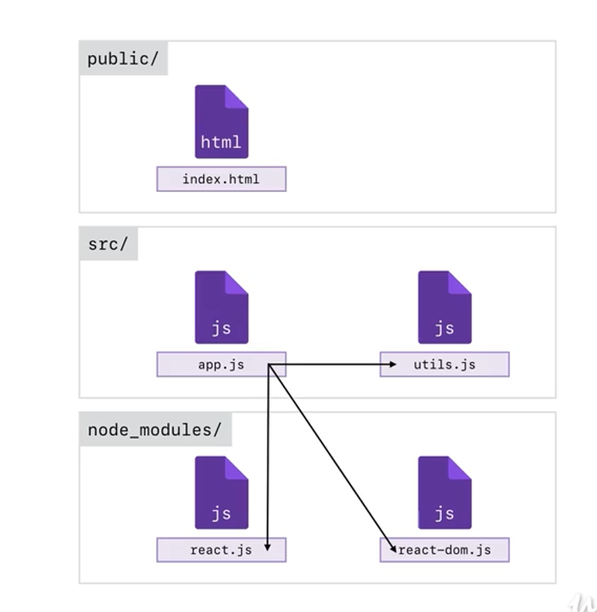Webpack is used as a Page Manager, which regulates and collects necessary js, html, css code parts into single page.

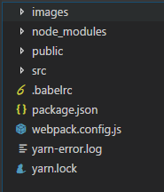ALL DATA (LIBRARIES) related to WebPack and other components are stored in **node_modules**.  
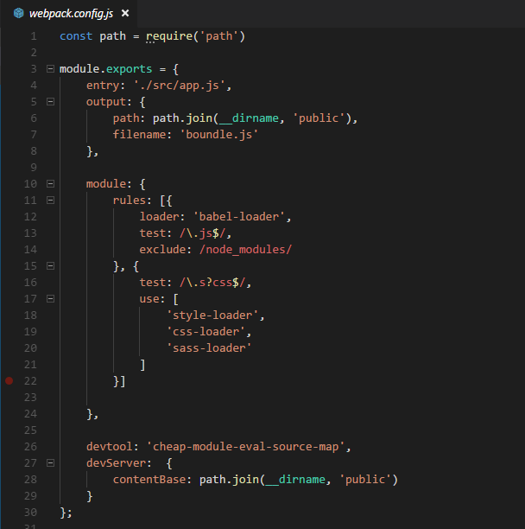

In screenshots above u can see that we take entry point to our site (app.js) and then after refactoring it we create a single boundle.js file so it already contains all necessary data required for particular task

1. **ReactJS**

It is used for a web application (in our case: Profiler form)

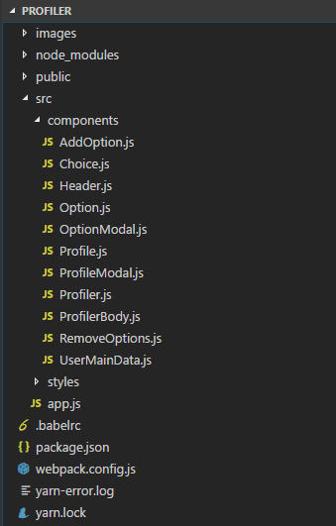

Here in a list you may find components folder. As you see web app itself divided into small parts.

They are actually classes, which contain reusable objects (in our case, they are Headers, Option panels and so on).

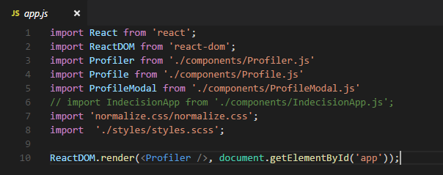

This is the entry point of Profiler page. Here all components are included

ReactDOM.render() – is responsible for construction of that components and rendering (styles) them into single html file with entry <div id=‘app’> tag.

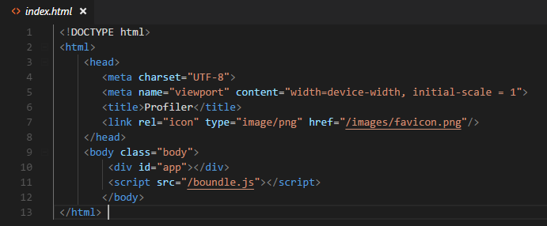

This is the actual page where the real magic happens (You can pass any type of web app, into a single html file)

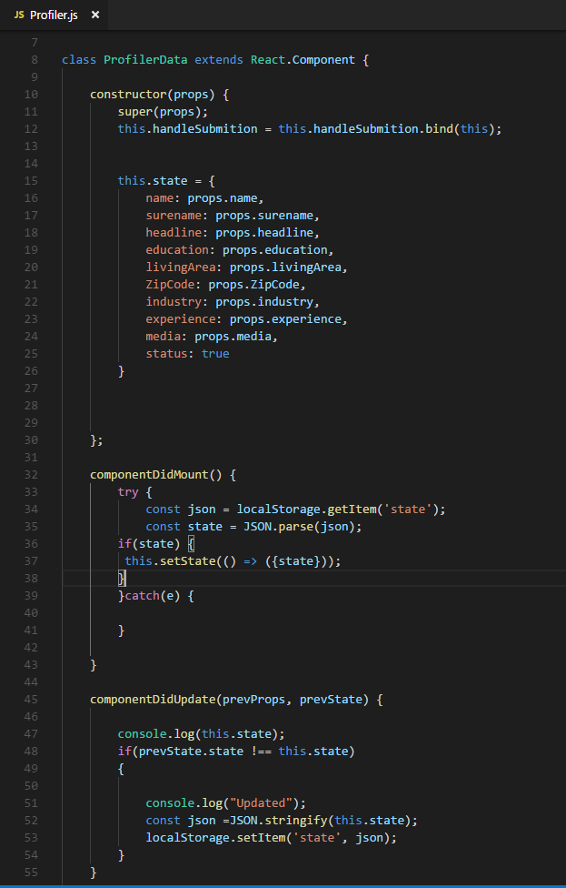

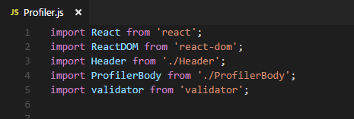

Profiler.js is the central code for Profiler app. It takes all peripheral components as Header, Body and Validator

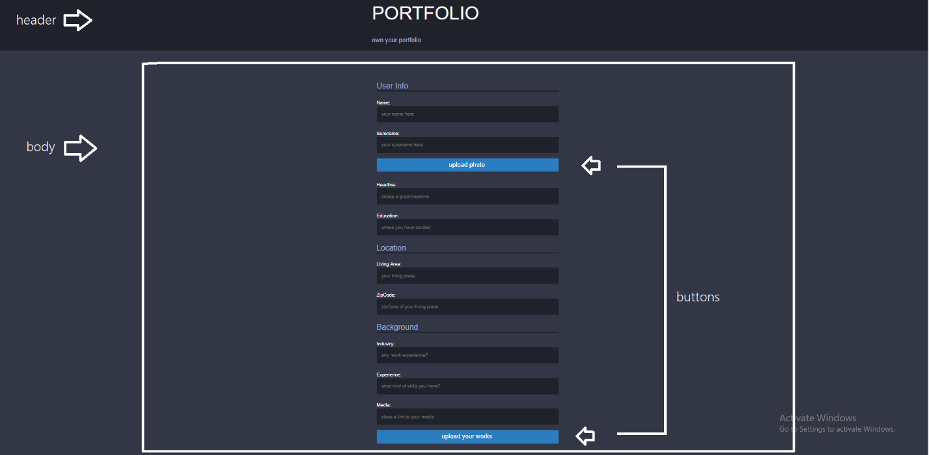

*Every items is reusable component

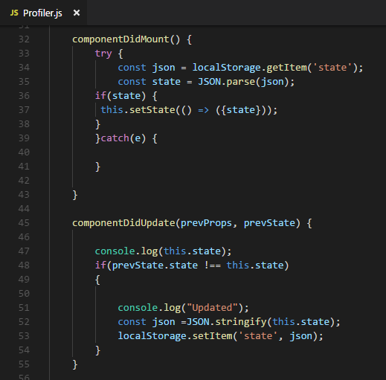

componentDidMount() and componentDidUpdate() stores your data typed into input fields in localStorage. So in case you unconsciously close your browserTab everything in this page will stay in places.

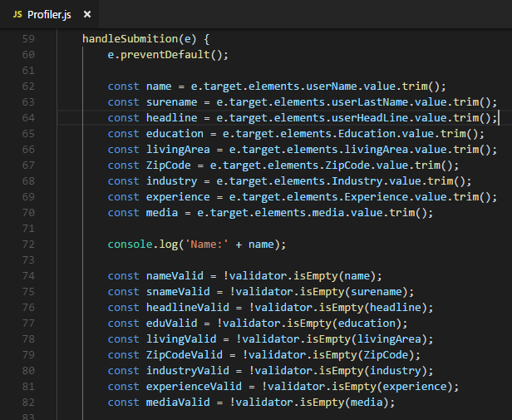

clientSide validator which is used for checking input data.

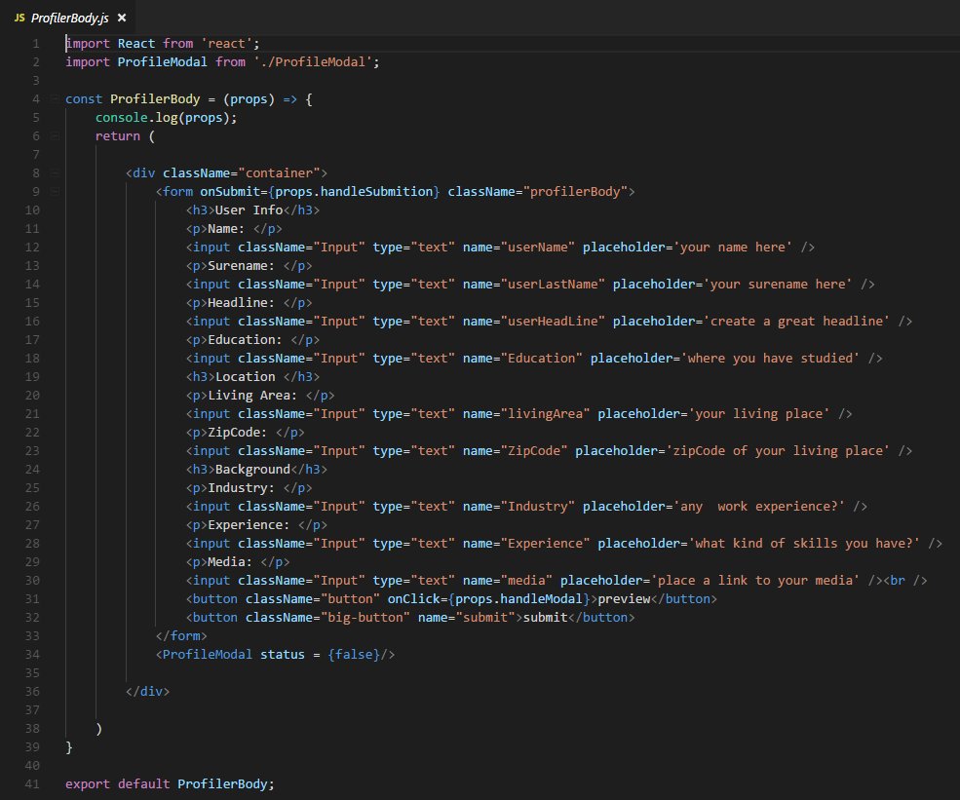

Body of Profiler app.

As you see, some components contain simple code so in this case we used **Stateless Functions** they are easier to compile rather than **classes.**

**BY THIS SIMPLE TRICK WE ARE ABLE TO INCREASE SITE LOADING SPEED!**

OTHER COMPONENTS:

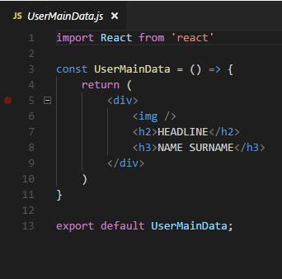

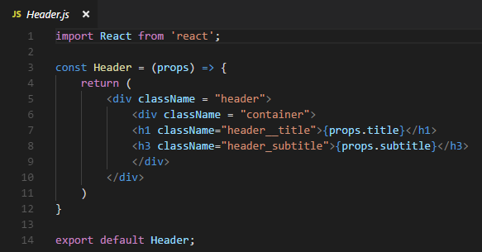

1. **BABEL**

Advantage of using Babel is in JavaScript. Different browsers support different versions of JS like ES6 or ES5. Babel is online tool which converts script into particular one supported by the browser.

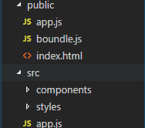

it takes base code from src folder ‘app.js’ and saves translated version in folder public ‘app.js’

This is ‘app.js’ in src folder:

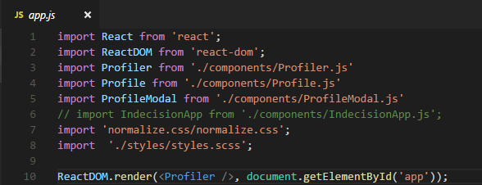

Translated ‘app.js’(ES5) in public folder:

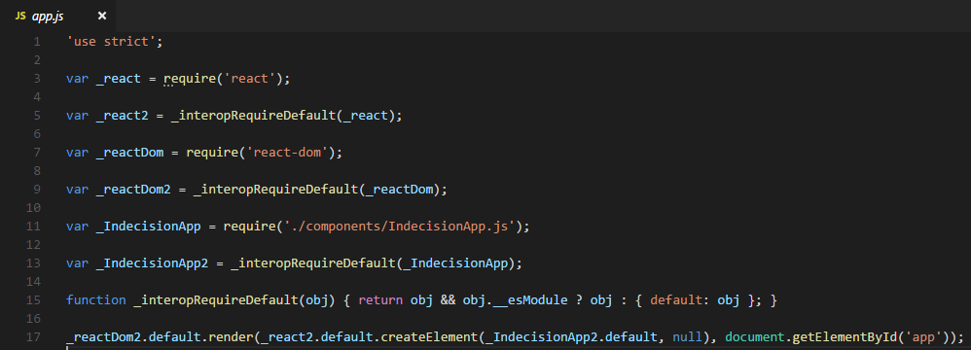

1. **SCSS**

CSS doesn`t allow us to use variables instead of repeating color codes, size, etc.

Therefore, SCSS is helpful in this case.

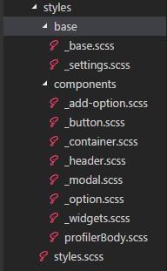In addition, SCSS gives ability to separate .css code into single code files.

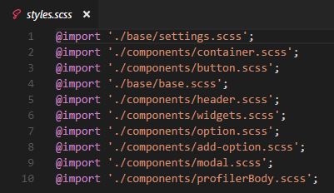

Styles.scss is an entry point to outlook of our web app. It includes every single-code file which is required for current web page.

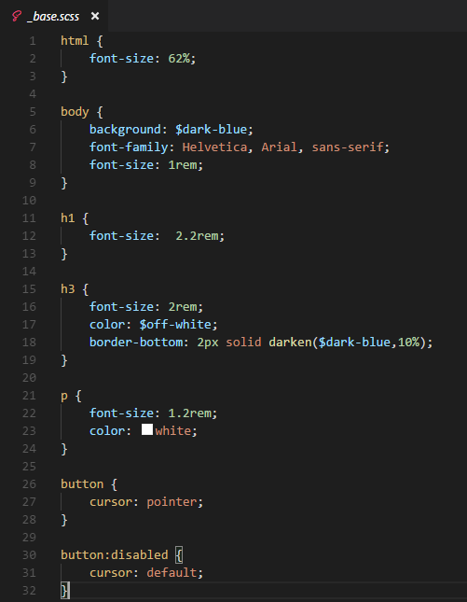

Base.scss contains basic properties of our page. It can be overwritten later as well.

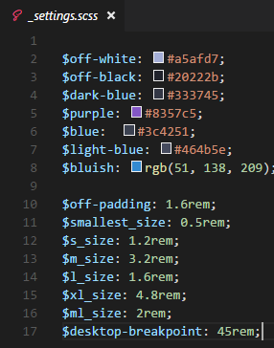in settings.scss we store variables which hold data related to color-codes and sizes.

Lastly, for running this application in browser you need a server, which allows to compile all components

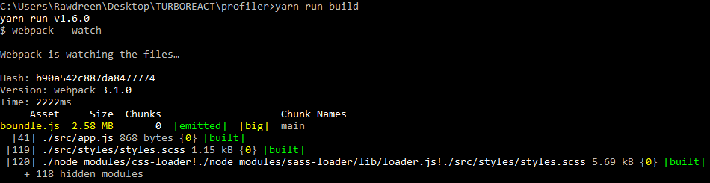

Yarn run build – runs webpack that will watch over application in run time.

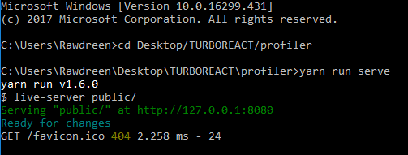

Yarn run serve – run server and opens up built web application in index.html

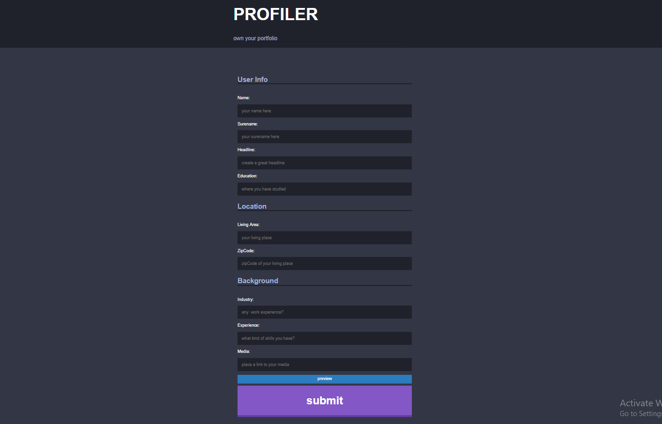

Here it is) (scale: 75%)

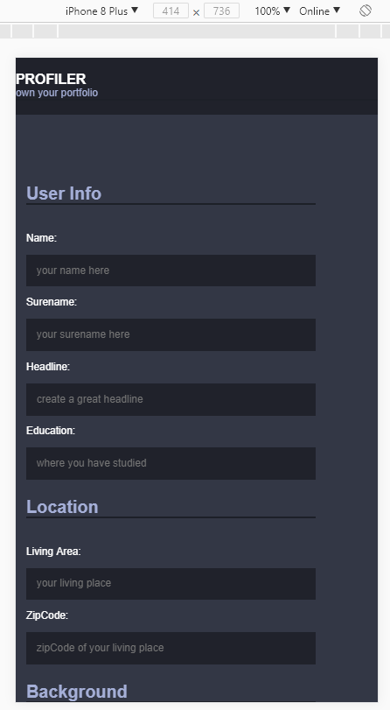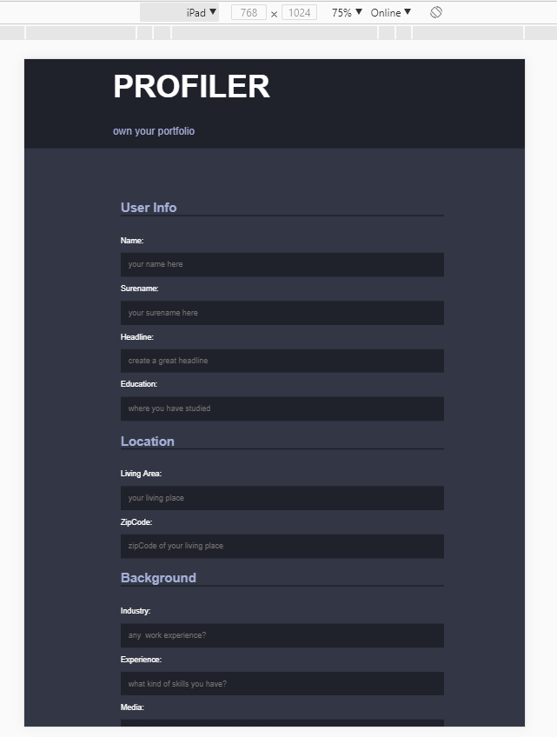

It is responsive as well

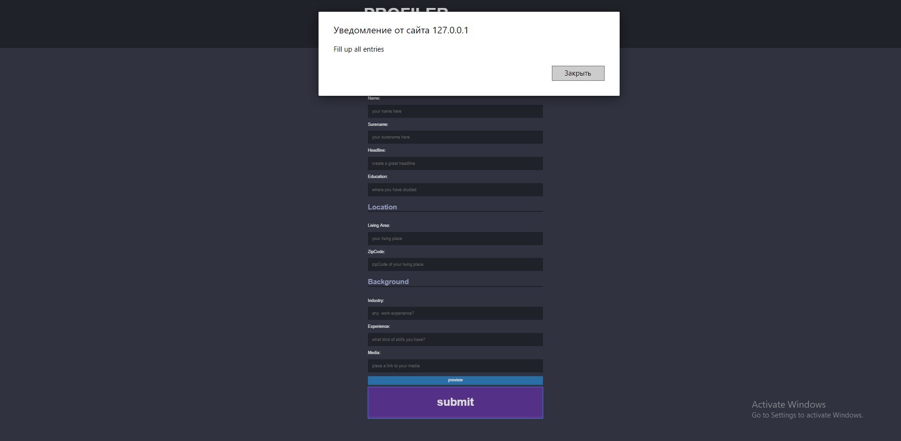

Input validation included (third-part component ‘Validator’)

**Head hunt:**

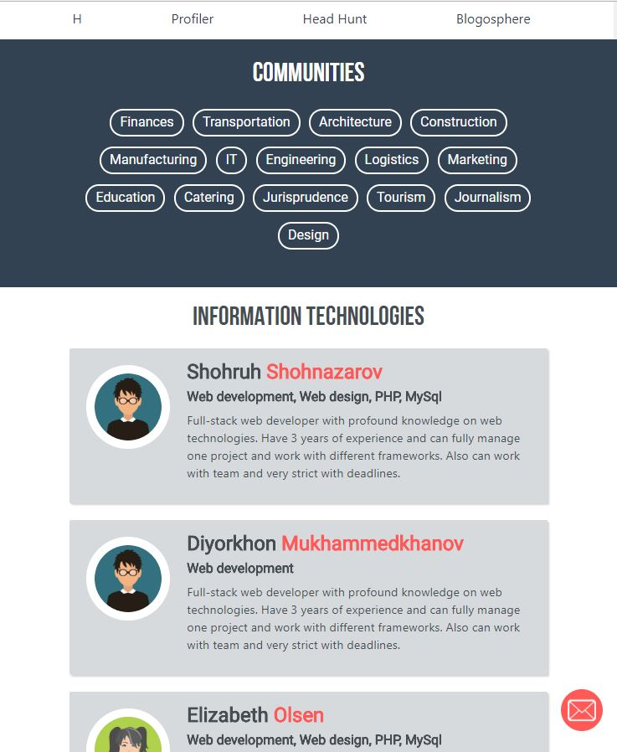

You go to **head hunt** page and will see list of all profiles. In order to find portfolios in different job sections select interested category from hashtag list. Design of this web page was made on css3 and bootstrap 4.

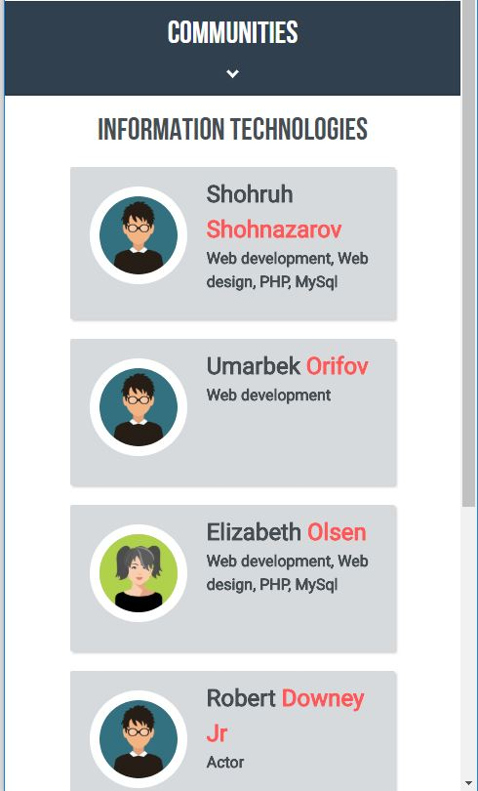

Web site is fully responsive so it can work in different devices. Responsiveness of web page was achieved using @media queries.

**Account:**

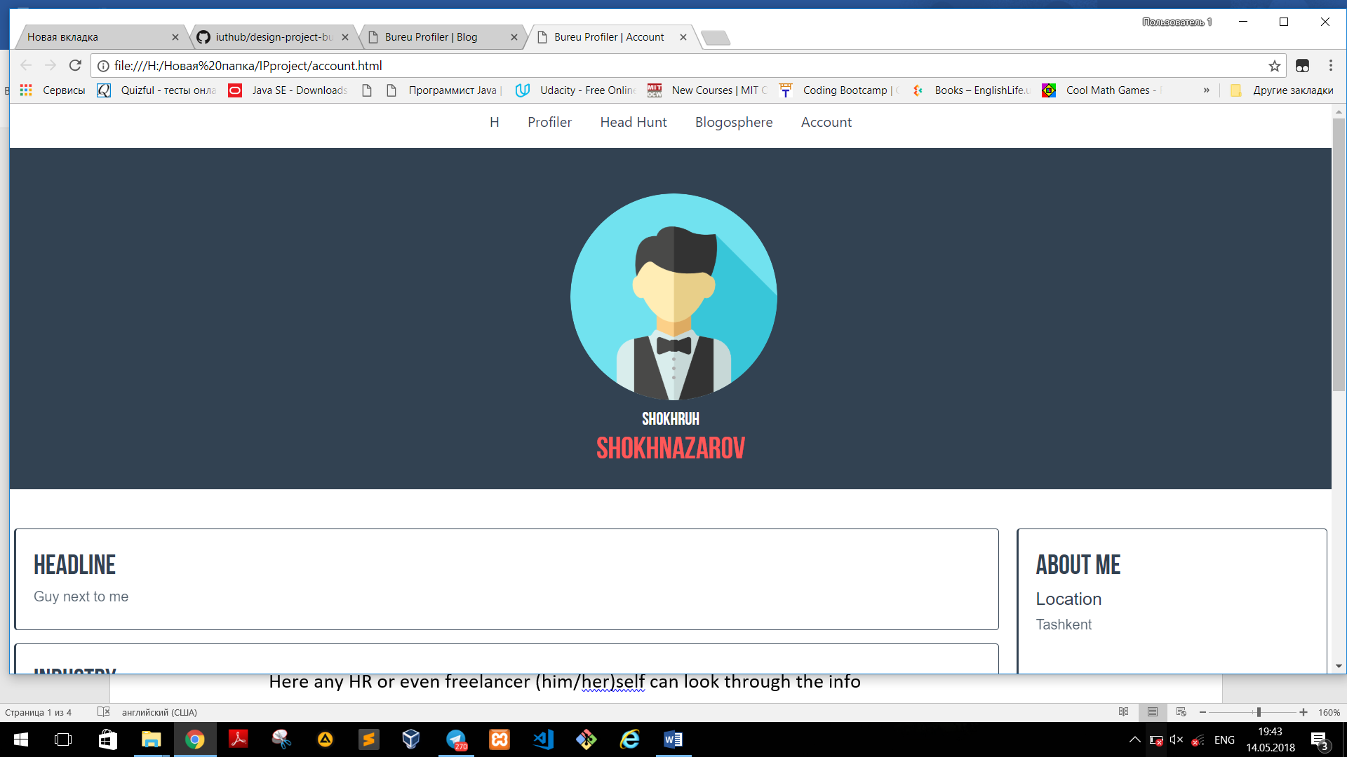

This is an user information page – account

Here any HR or even freelancer (him/her)self can look through the info

Image is responsive

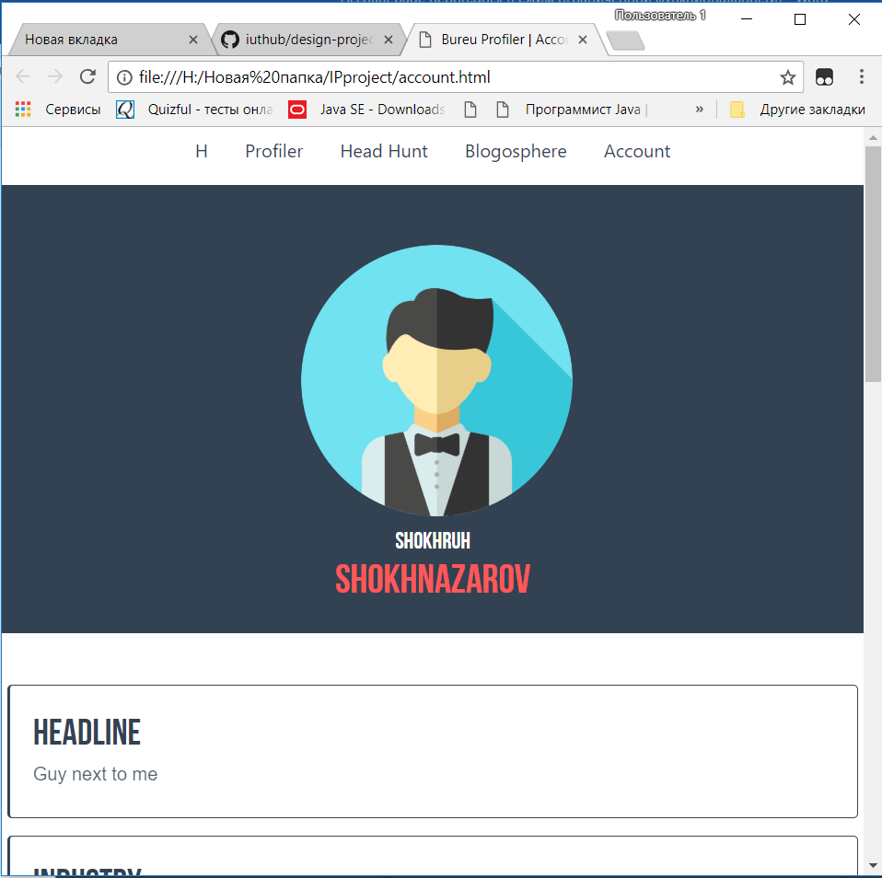

Then, it’s the user’s portfolio

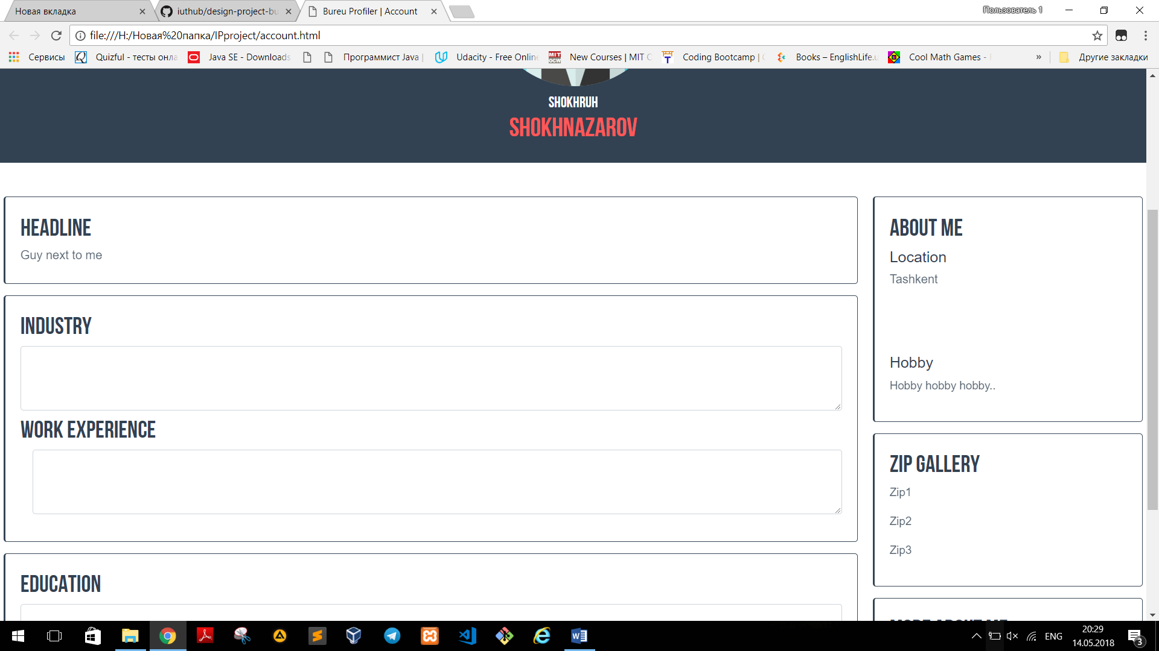

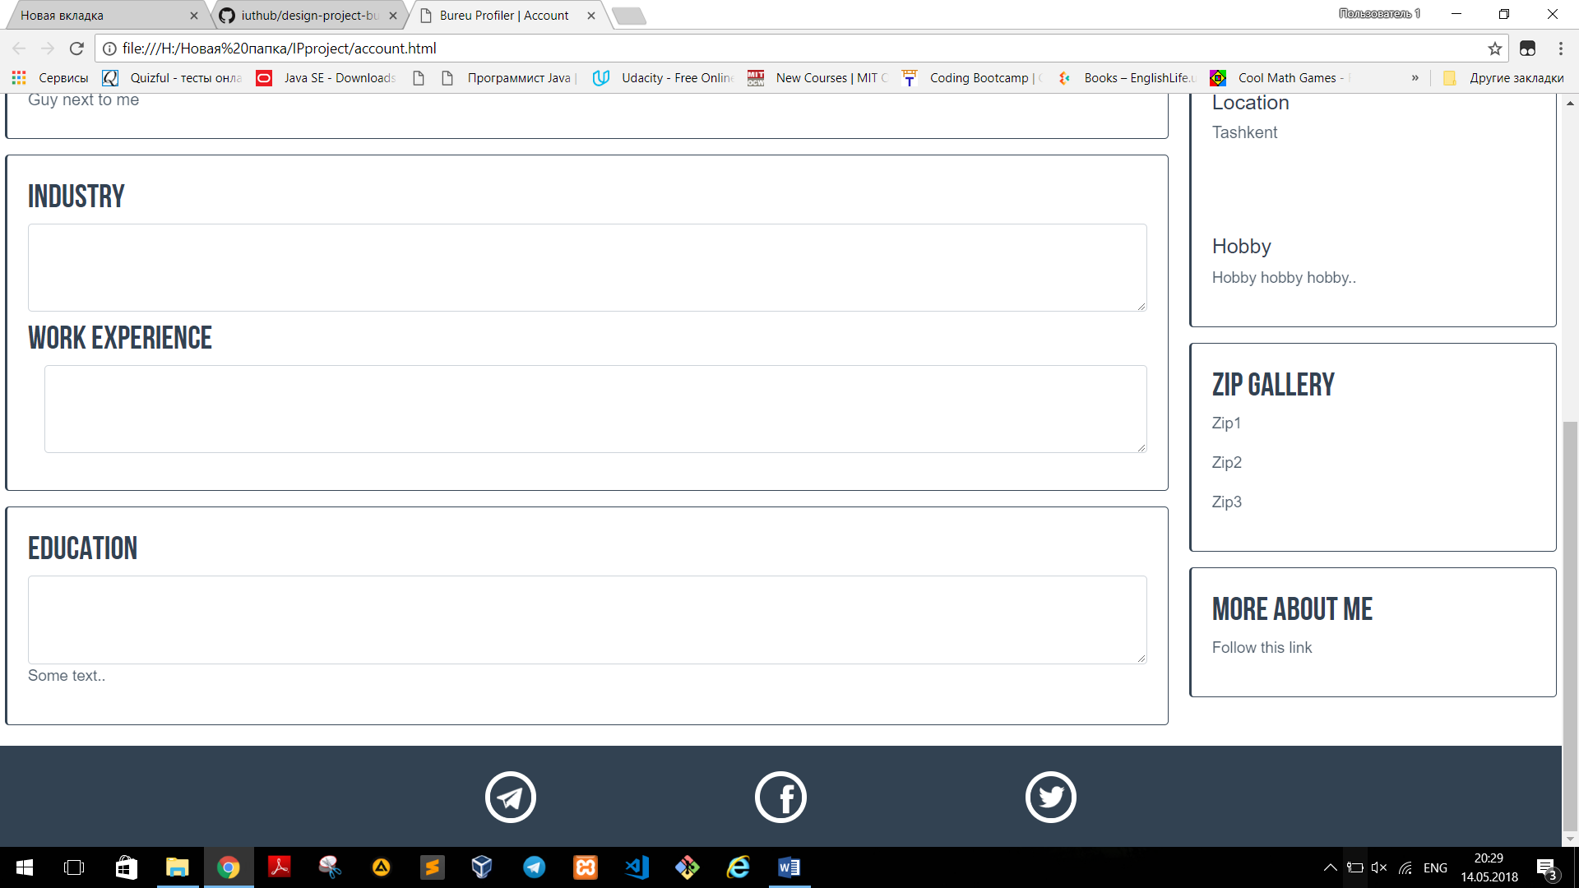

Footer is like-a-contact-us block

By clicking on icons one can find more information or set up the direct contact

For example, first icon – Telegram Messenger

Click

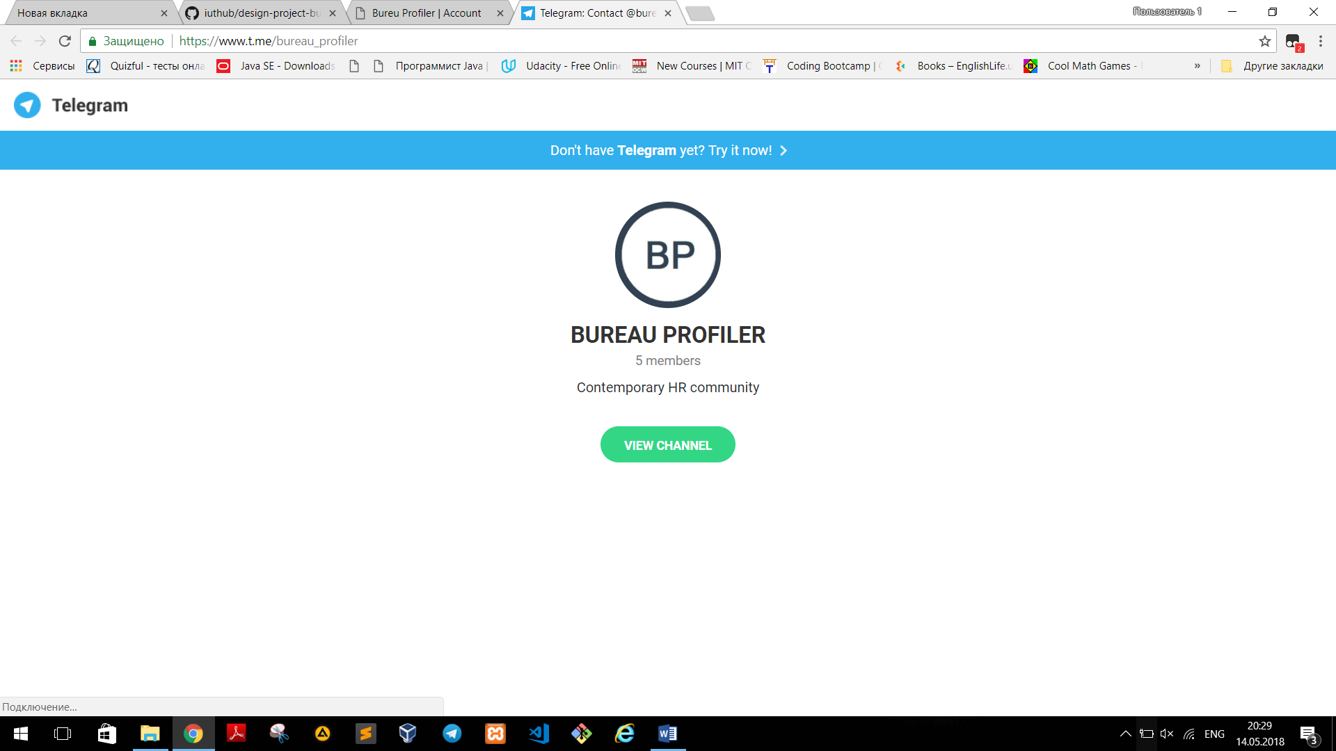

Our telegram channel

Subscribe.

**Laravel:**

Our project is located in folder ip_Project

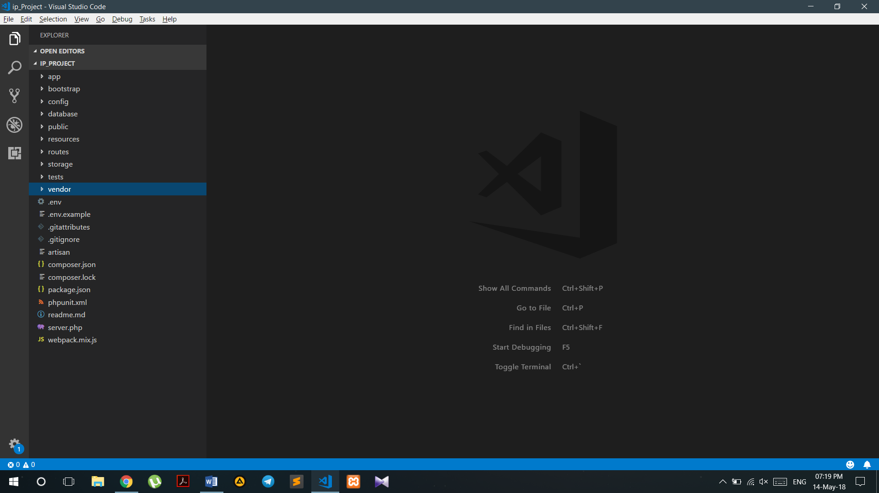

We have 4 pages in the folder *pages*:

* index.blade.php
* profiler.blade.php
* head.blade.php
* blog.blade.php

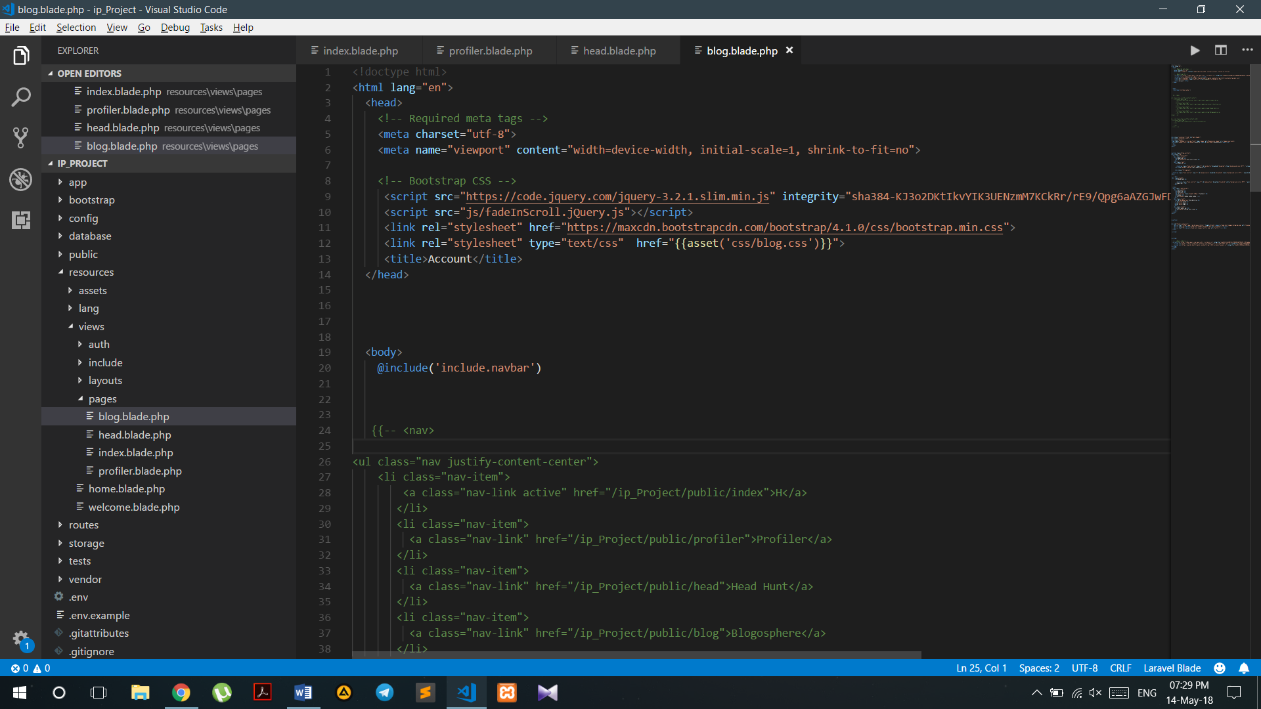

In *routes* folder there is web.php, where we have created 5 *routes* using PagesController

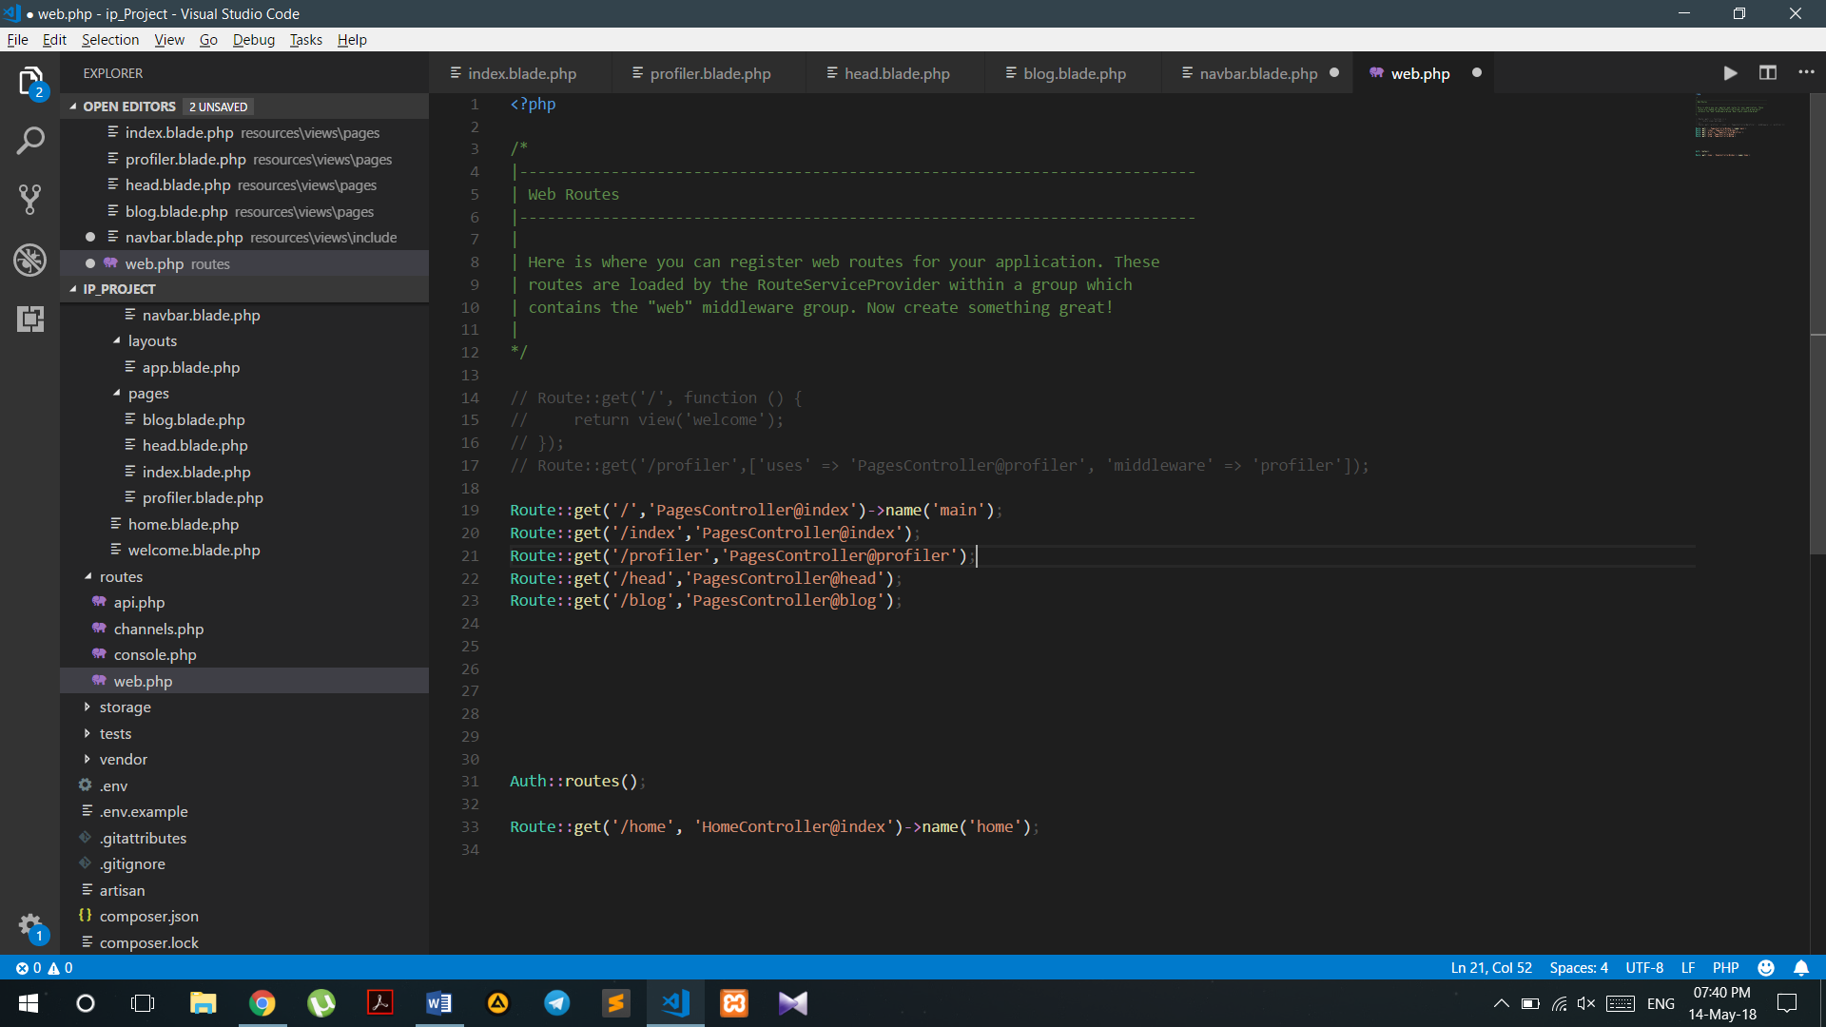

There are function that return pages

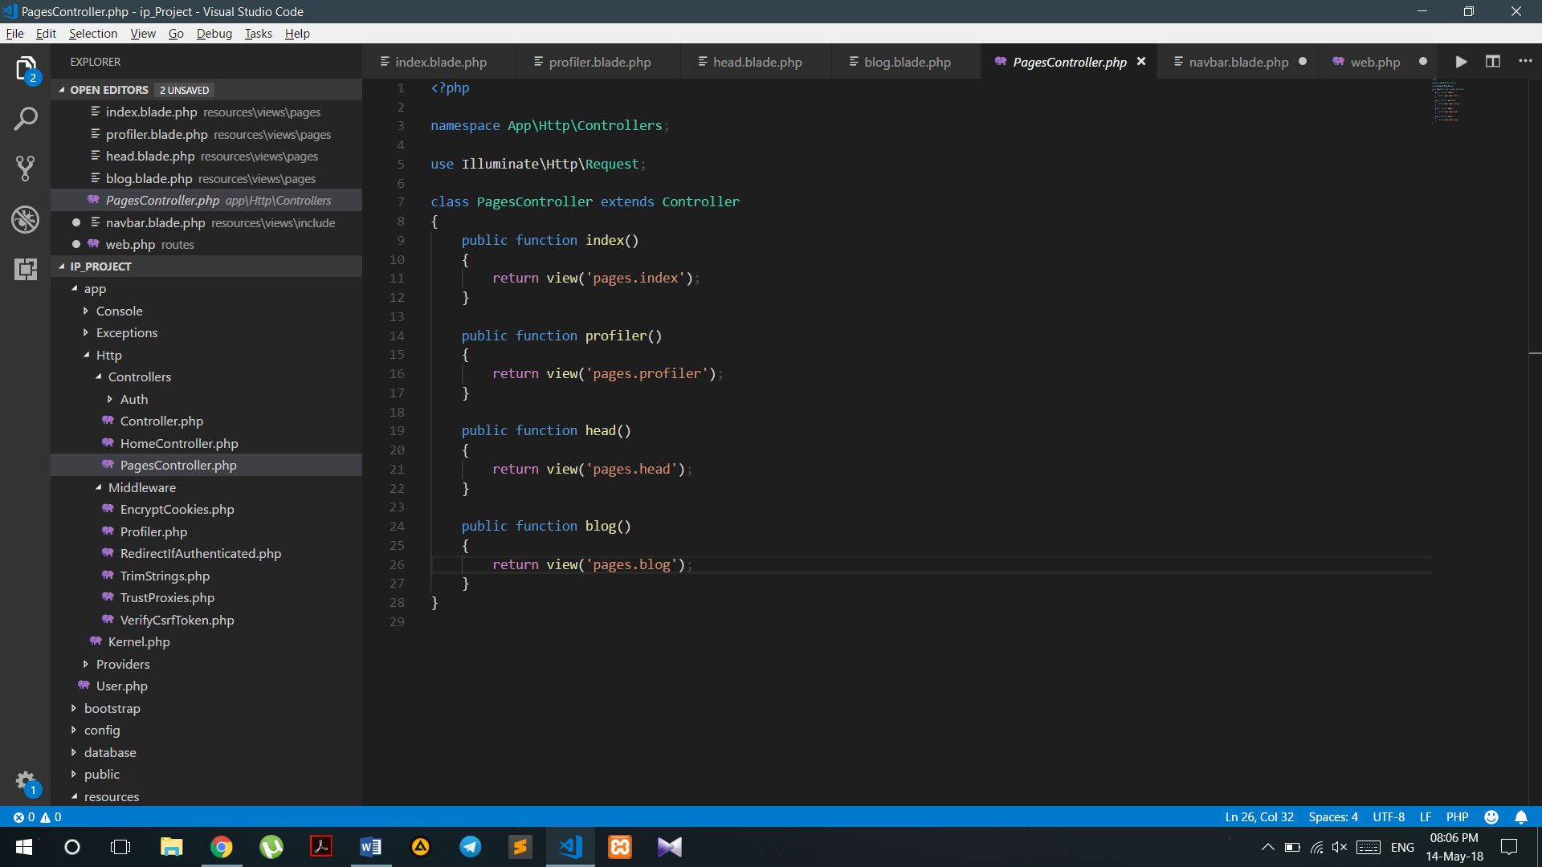

In the folder *include* there is navbar.blade.php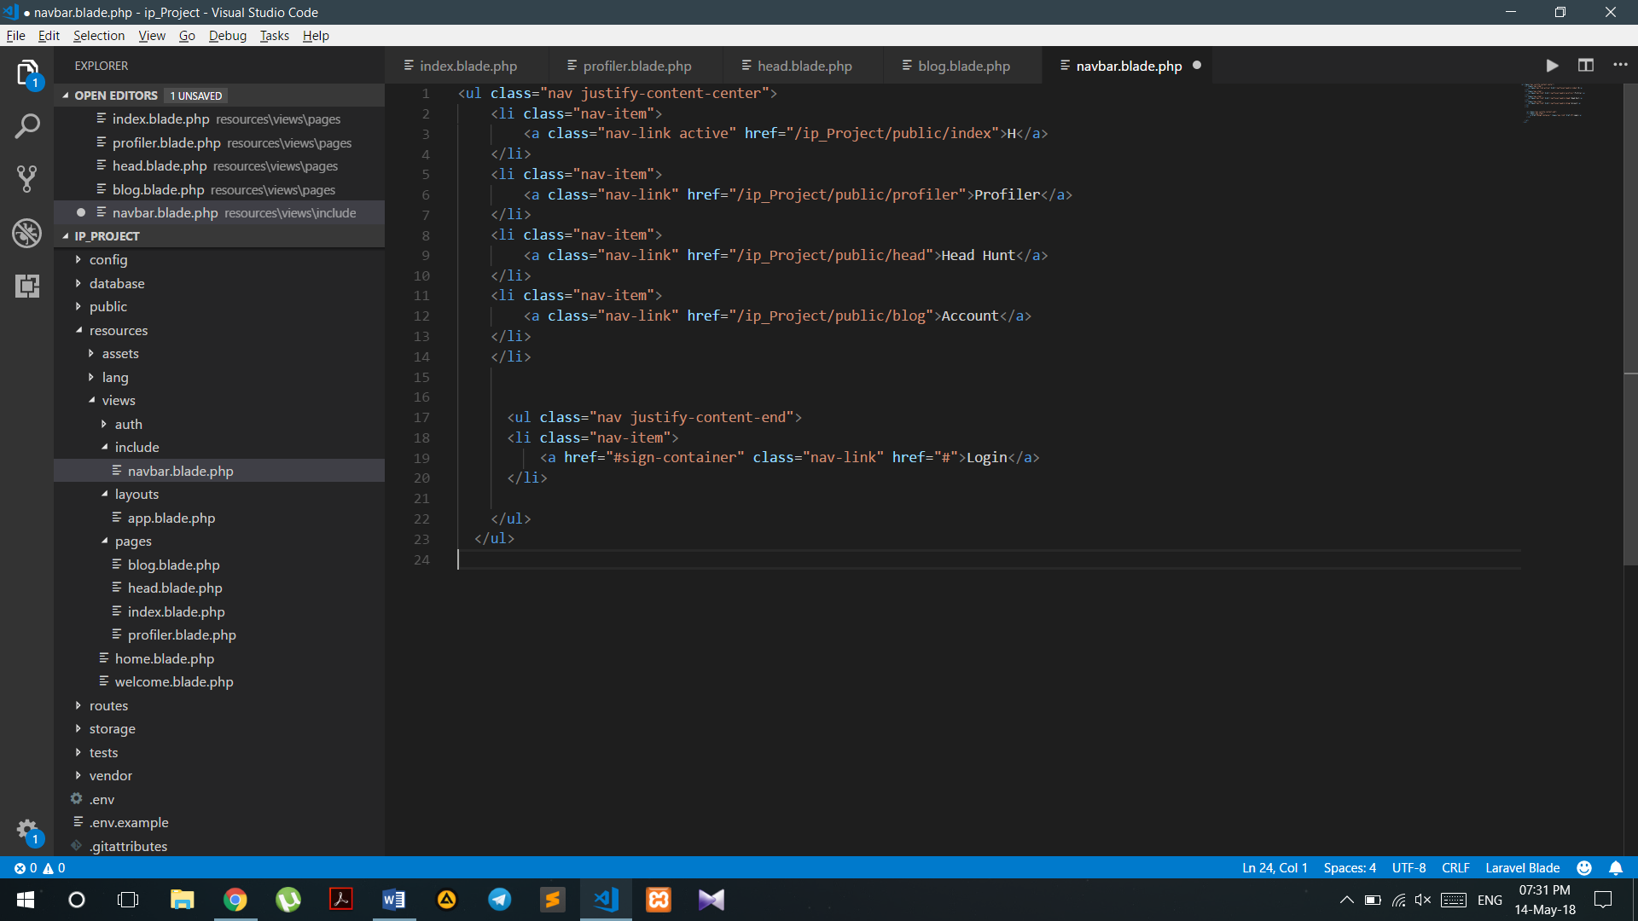

That we use in all 4 pages using *@include* command

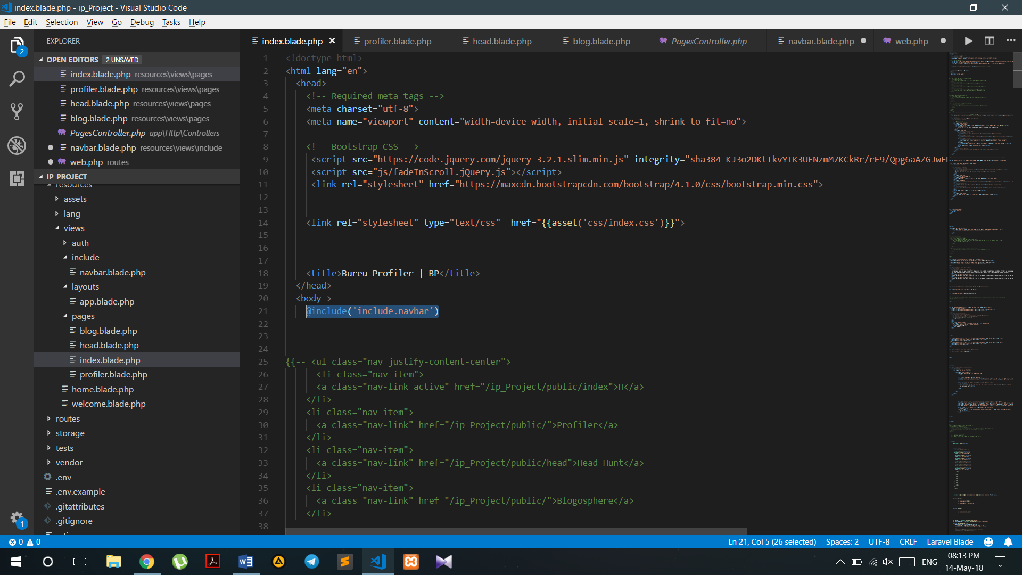

**Contributors:**

**Diyorkhon Mukhammedkhanov:**

“I was acting like a fulll-stack pro in my team. I did a client-side js page Account(in accordance with material design ) . In my part I used Jquery, Bootstrap that made my front-end responsive”

**Rodion Akhmedov:**

“Home page completely is my contribution to the project. I was responsible for flexible , responsive front-end. I used JS, Jquery and Bootstrap”

**Abdullokh Askarov:**

“U1610005

Profiler was my part of the project it includes followings:

Technologies in use:

1. Webpack

2. ReactJS

3. Babel

4. SCSS

AIM:

The main idea of this part of a project was to develop a single dynamic page with reusable components.”

**Shokhrukh Shokhnazarov:**

“I was responsible for Head-Hunt page. I have developed it using css3 and bootstrap from scratch. Made the web page responsive for different devices”

**Umarbek Orifov:**

**“**I did a backend development. I have linked pages using laravel framework through controller and also used php functions to implement some html codes **”**

**Summary:**

Due to the time limits we were unable to implement database and make our website fully functional. And we also were unable to connect React to Laravel. So in a web hosting we have uploaded only html and css files so and implemented Profiler page with css. You can see our whole work on github